**DS – 5306 Lab #2: Bully Coordinator Election Algorithm**

**Name: Akshay Sarkar; UTA Id: 1001506793; Login ID: axs6793**

**Write up of the Lab #2:**

**System Environment:**

Environment Required: Java Virtual Machine

Language: Java

**Instructions for running program:**

1. We need to first put all the files of zip under one directory (E.g : C:\BullyAlgorithm).
2. (Skip this step if you have already have JAVA_HOME Environment setup in your system)

You need to install Java Virtual Machine in your computer. Follow this [video link](https://www.youtube.com/watch?v=Wp6uS7CmivE) for setup.

1. Once you are completed with Java Environment Setup, now move back to the directory under command line (cmd). Type ‘javac’ to verify the setup completion. (See below figure)

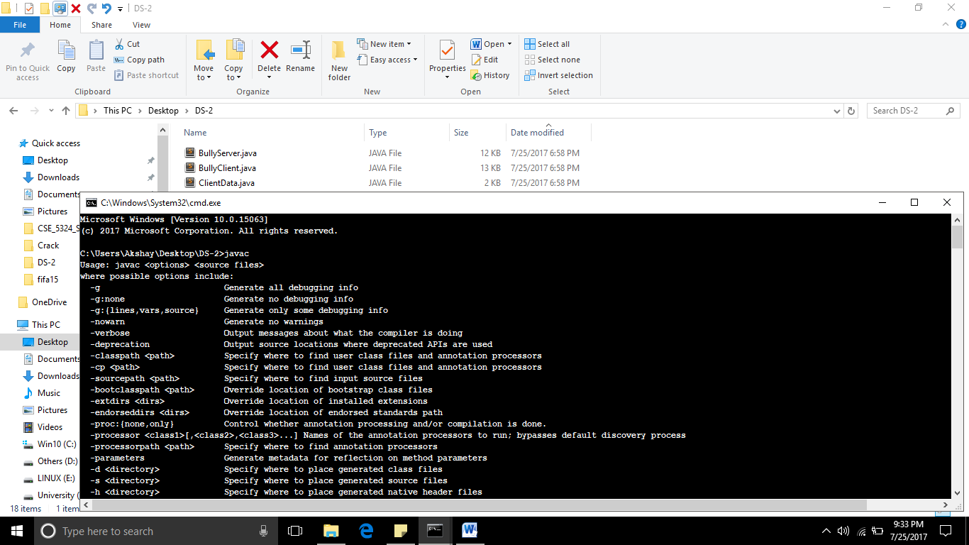

1. Next run the CompileAll.bat (bat file) to compiles all the files. It will generate few class files.

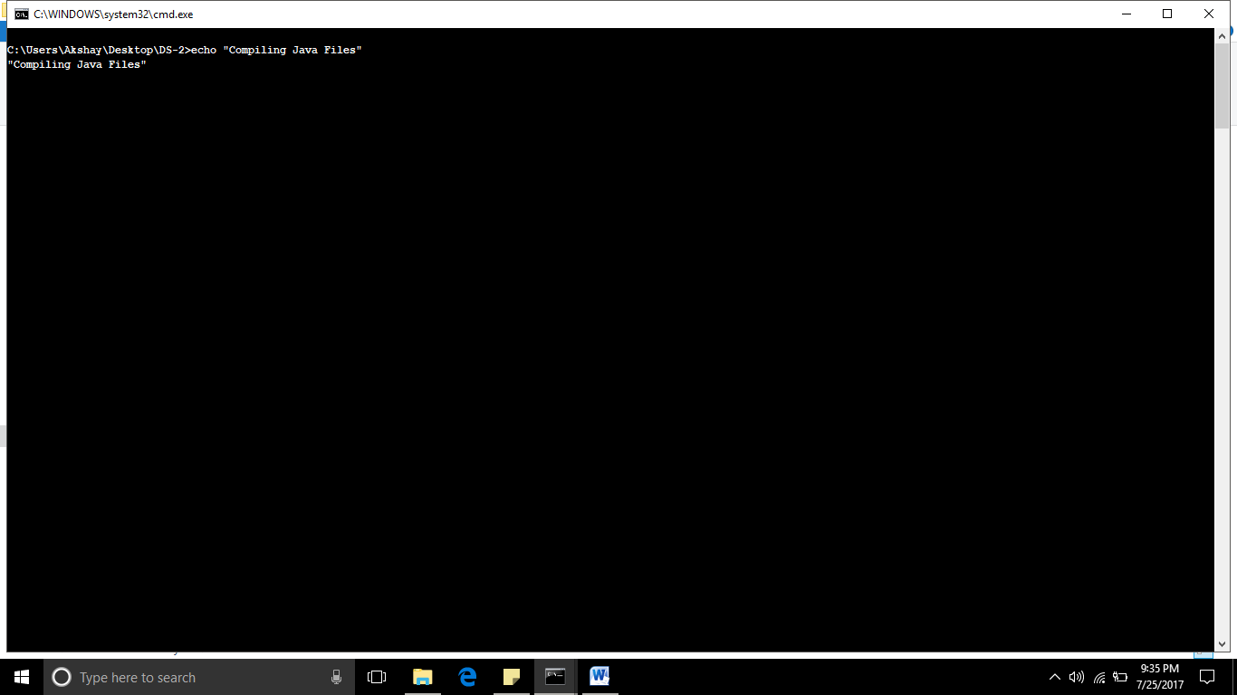

1. Next step is run the client and Server one by one.

* To run server, double click on ‘RunServer.bat’. It would open up Server UI automatically.

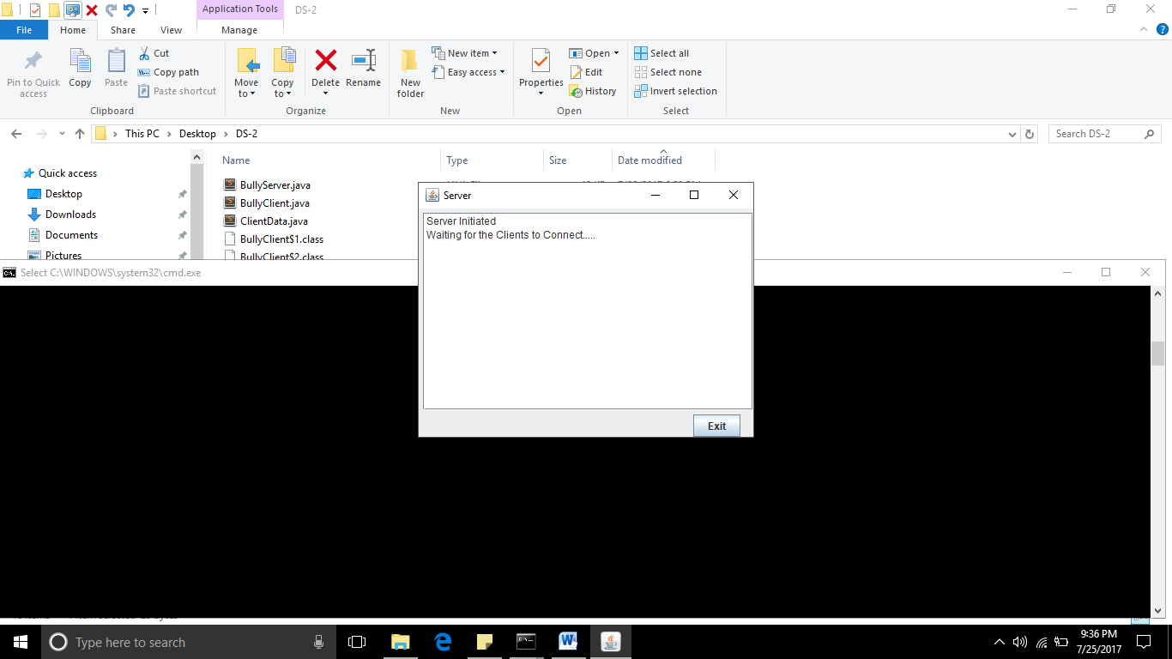

* Second will run the client, by double click on ‘RunClient.bat’. It would open up Client UI.

You need to provide every client a unique name and process id (See below figure). Multiple clients can be created using same steps.

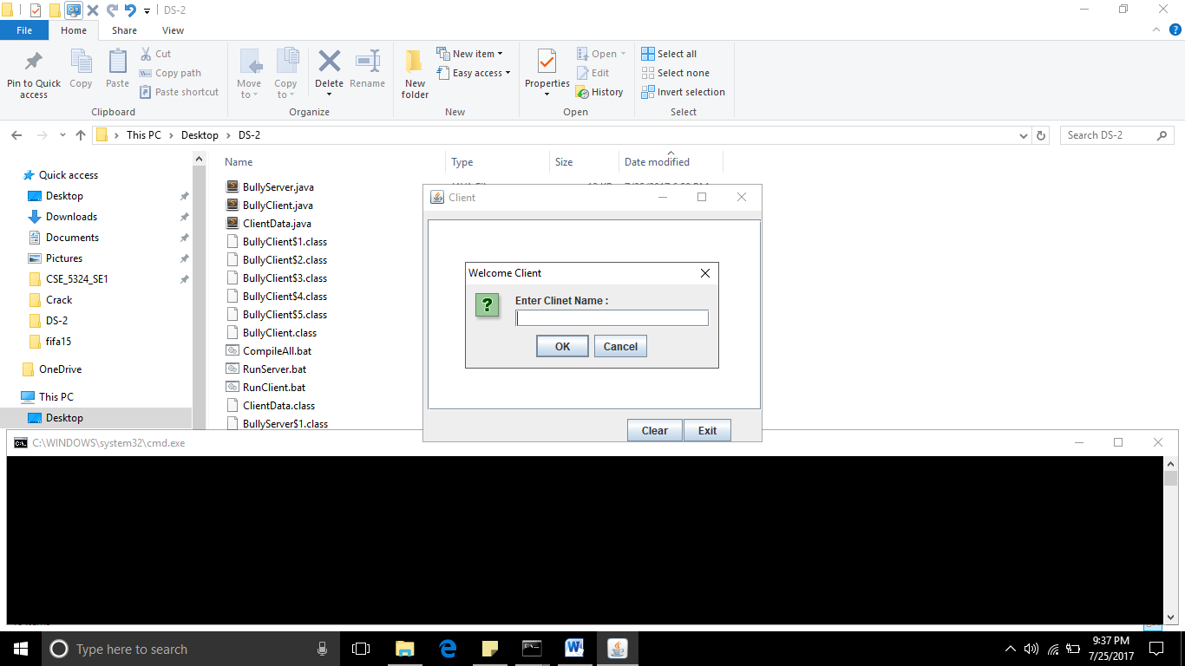

1. Now your application is completely running.

You could start testing the bully algorithm. The text-area would show you all the logs that are happening on both client and server.

**References:**

1. [http://cs.lmu.edu/~ray/notes/javanetexamples/#chat](http://www.google.com/url?q=http%3A%2F%2Fcs.lmu.edu%2F~ray%2Fnotes%2Fjavanetexamples%2F%23chat&sa=D&sntz=1&usg=AFQjCNG0D-1m4V47bt6sU682R6ntW1E2qQ)
2. <http://www.mysamplecode.com/2011/12/java-multithreaded-socket-server.html>
3. <http://docs.oracle.com/javase/tutorial/networking/sockets/clientServer.html>

**Zip Contents:**

1. WriteUp_Lab_2.docx
2. BullyServer.java – Server Code
3. BullyClient.java – Client Code
4. ClientData.java – Client POJO(Plain Old **Java** Object)
5. CompileAll.bat – To compiles all the java files
6. RunServer.bat – To run server
7. RunClient.bat – To run client

**Note:** 1. Doesn’t contain any known bug or issue.

2. Special case, like starting election when only one client/node is been handled.

3. Every node/client must have a unique name; we could think it as an IP Address identifier between multiple nodes.